**NBTX10442_WEEK-6_LAB-B**

Q1.

#include<stdio.h>

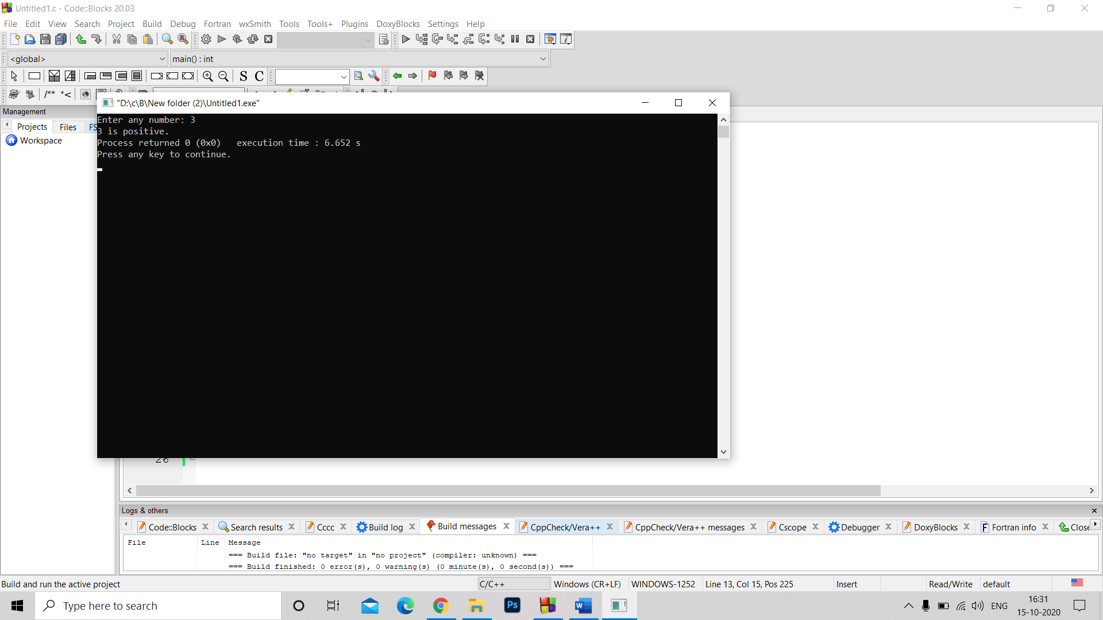#include<stdlib.h>

int main()

{

int a;

printf("Enter any number: ");

scanf("%d",&a);

switch (a > 0)

{

case 1:

printf("%d is positive.", a);

break;

case 0:

switch (a < 0)

{

case 1:

printf("%d is negative.", a);

break;

case 0:

printf("%d is zero.", a);

break;

}

break;

}}

Q2. #include<stdio.h>

#include<stdlib.h>

int main()

{

float a,b;

int ch;

printf("Enter 2 numbers : \n");

scanf("%f%f",&a,&b);

printf("1.Addition \n 2.Multiplication \n 3.Subtraction \n 4.Division \n");

printf("enter your choice \n");

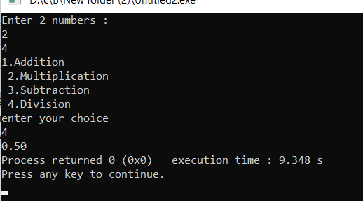 scanf("%d",&ch);

switch(ch)

{

case 1 : printf("%0.2f",a+b) ;

break;

case 2 : printf("%0.2f",a*b) ;

break;

case 3 : printf("%0.2f",a-b) ;

break;

case 4 : printf("%0.2f",a/b) ;

break;

default:printf("invalid choice") ;

}

}

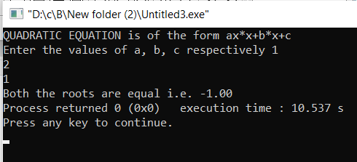Q3. #include<stdio.h>

#include<stdlib.h>

int main()

{

int a,b,c,d;

float r1,r2;

printf("QUADRATIC EQUATION is of the form ax*x+b*x+c \n");

printf("Enter the values of a, b, c respectively ");

scanf("%d%d%d",&a,&b,&c);

d=b*b-4*a*c;

r1=(-1*b + sqrt(d))/(2*a);

r2=(-1*b - sqrt(d))/(2*a);

switch(d<0)

{

case 1:printf("no real roots");

break;

case 0: switch (d > 0)

{

case 1:

printf("roots are %0.2f , %0.2f .",r1,r2);

break;

case 0:

printf("Both the roots are equal i.e. %0.2f ",r1);

break;

}

break;

}

}

Q4. int main()

{

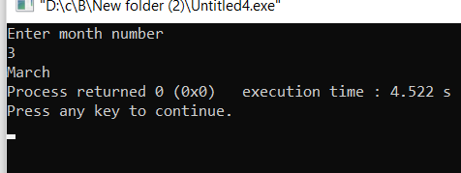

int ch;

printf("Enter month number\n");

scanf("%d",&ch);

switch(ch)

{

case 1 : printf("January") ;

break;

case 2 :printf("Feburary") ;

break;

case 3 : printf("March") ;

break;

case 4 :printf("April") ;

break;

case 5 :printf("May") ;

break;

case 6 :printf("June") ;

break;

case 7 :printf("July") ;

break;

case 8 :printf("August") ;

break;

case 9 :printf("September") ;

break;

case 10 :printf("October") ;

break;

case 11 :printf("November") ;

break;

case 12 :printf("December") ;

break;

default:printf("invalid input") ;

}

}